MASTER DOSSIER – Atmospheric Resilience Projector (ARP)
Civil Protection Node – Theoretical Research Framework v0.3
Classification: Non‑Weaponized Infrastructure (Civil Protection System)
Status: Iterative document for physical, environmental, and ethical evaluation

1. Humanitarian Scope & Purpose
The ARP system is designed exclusively as reactive, civilian protection infrastructure.

“The Atmospheric Resilience Projector (ARP) is designed as a purely reactive, civilian protection infrastructure.”

“A technical activation is only possible when an external wavefront is detected. Offensive use is therefore excluded.”

Primary protection targets
• Hospitals
• Drinking water infrastructure
• Power grids
• Evacuation routes

Operational principle
• Reactive coupling: The system cannot activate without an incoming shockwave, radiation front, or fallout cloud.
• Local effect: The protection volume is limited to a defined corridor or shield over area X — not a planetary defense system.

2. Physical Specification & Core Mechanisms

2.1 Atmospheric Gradient Lens (Shockwave Manipulation)
The ARP uses a plasma or heated‑air column to create a density and temperature gradient in the atmosphere.

“The plasma column acts explicitly as a gradient lens for shockwaves. It uses density and temperature gradients to refract and deform the Mach front.”
“The goal is defined as targeted fragmentation and turbulence induction of the shock front.”

Mechanism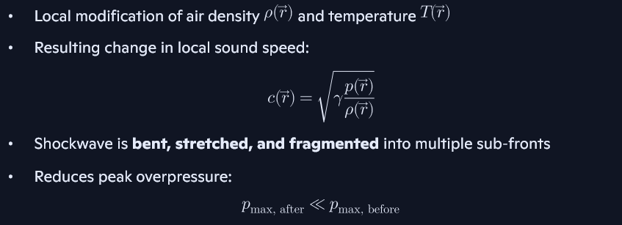

Research tasks
• CFD simulation of compressible flow + shock interaction
• Optimization of gradient geometry
• Thermal stability under real atmospheric conditions

2.2 Radiological Protection

2.2.1 Neutron Absorption

“Main focus: absorption of neutrons and binding of fallout.”

The ARP deploys boron or gadolinium‑based aerosols to absorb neutrons.
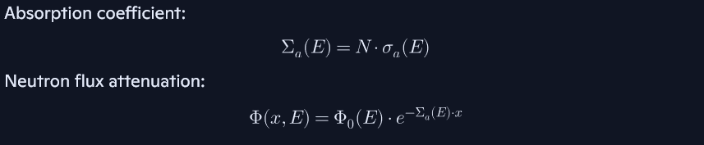

2.2.2 Fallout Binding & Ground Fixation

“A mechanism for hardening or gel formation fixes radioactive particles to the ground.”

Mechanisms:
• Polymer‑based aerosol carriers
• Gel‑forming agents for surface fixation
• Reduction of airborne resuspension

Research tasks
• Environmental toxicology
• Long‑term stability
• Decontamination strategies

2.3 Magnetic Field (Secondary Electron Deflection)
“The magnetic field serves exclusively to deflect secondary electrons, not primary gamma quanta.”

Function
• Deflect Compton electrons
• Reduce secondary ionization
• Improve local shielding efficiency

Research tasks
• Field geometry optimization
• Coupling with plasma column
• Energy efficiency

3. Control Model & System Metrics

3.1 Sensor → Prediction → Activation Chain

“The chain runs from sensors (radar/lidar/infrasound) through wavefront prediction to plasma ignition and counter‑impulse.”

Pipeline


3.2 Synchronization Metric S (Phase Error)


3.3 Resilience Index R & Duty Cycle

“The system operates in burst mode and requires regeneration time after major events.”


Research tasks
• Energy storage optimization
• Material consumption modeling
• Regeneration cycle analysis

4. Swarm‑Capable Architecture

4.1 Concept

Multiple autonomous Civil Protection Nodes form a distributed protection network.

Each node includes:
• Atmospheric Gradient Emitter
• Aerosol Dispersion Module
• Magnetic Induction System
• Sensor suite
• Autonomous control logic

4.2 Swarm Logic

Objectives

Research tasks
• Multi‑agent coordination
• Fault‑tolerant communication
• Ethical fail‑safe mechanisms

5. Civil Protection Node – Vehicle Platform

“The system is defined as a capacity‑limited protection field.”

5.1 Mechanical Platform
• Fully autonomous, no cockpit, no windows
• Rubberized crawler tracks (civilian‑grade)
• Standard headlights
• Orange rotating beacon
• Modular roof mount for protection systems

5.2 Integrated Modules

Atmospheric Gradient Emitter
• Plasma column
• Temperature/density gradient generation

Aerosol Dispersion Modules
• Boron/Gd carriers
• Fallout fixation agents

Magnetic Induction System
• Secondary electron deflection

Sensor Suite
• Radar
• Lidar
• Infrasound
• Radiation sensors
• Environmental sensors

6. Open Scientific Questions

Shockwave Physics
• How strong can gradient‑based shock manipulation realistically be?
• What are optimal plasma geometries?

Plasma Engineering
• Energy requirements
• Atmospheric stability

Aerosol Chemistry
• Environmental impact
• Optimal particle size distribution

Radiation Physics
• Realistic neutron attenuation factors
• Fallout binding efficiency

Control Theory
• Robust synchronization under uncertainty
• Multi‑node coordination
Experimental Validation
• Shock tube experiments
• Plasma column tests
• Field trials with inert aerosols

7. Character of the Project

This dossier is not a blueprint for a deployable system.

It is a scientific exploration framework intended for:
• Physicists
• Chemists
• Environmental scientists
• Control engineers
• Ethicists
• Emergency management researchers

Its purpose is to enable investigation, not to claim feasibility.

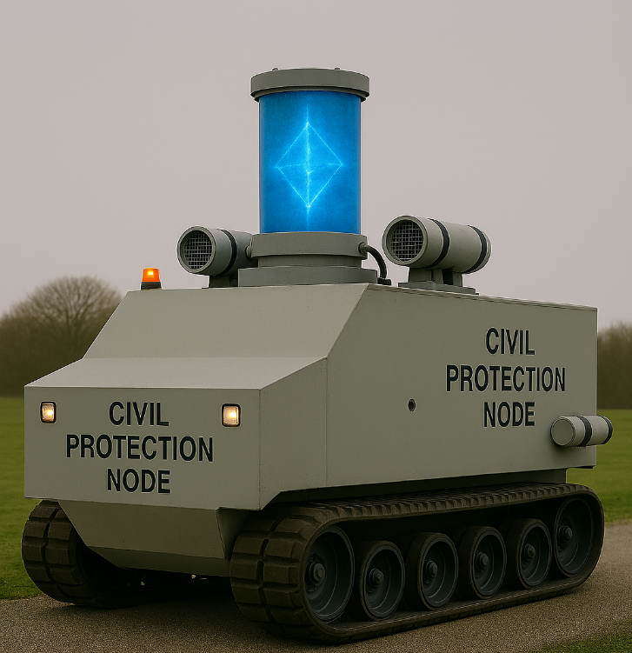

Functionality:
